Given a || b and c || d, use the figure below to name the relationship between the following pairs of angles:

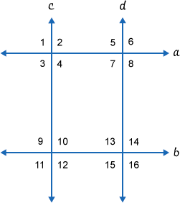

1.https://my.westcottcourses.com/images/common/angleNOarc.gif6   and   https://my.westcottcourses.com/images/common/angleNOarc.gif3

2.https://my.westcottcourses.com/images/common/angleNOarc.gif14   and   https://my.westcottcourses.com/images/common/angleNOarc.gif11

3.https://my.westcottcourses.com/images/common/angleNOarc.gif9   and   https://my.westcottcourses.com/images/common/angleNOarc.gif4

4.https://my.westcottcourses.com/images/common/angleNOarc.gif13   and   https://my.westcottcourses.com/images/common/angleNOarc.gif8

5.https://my.westcottcourses.com/images/common/angleNOarc.gif12   and   https://my.westcottcourses.com/images/common/angleNOarc.gif13

6.https://my.westcottcourses.com/images/common/angleNOarc.gif4   and   https://my.westcottcourses.com/images/common/angleNOarc.gif5

7.https://my.westcottcourses.com/images/common/angleNOarc.gif6   and   https://my.westcottcourses.com/images/common/angleNOarc.gif14

8.https://my.westcottcourses.com/images/common/angleNOarc.gif2   and   https://my.westcottcourses.com/images/common/angleNOarc.gif10

9.https://my.westcottcourses.com/images/common/angleNOarc.gif4   and   https://my.westcottcourses.com/images/common/angleNOarc.gif8

10.https://my.westcottcourses.com/images/common/angleNOarc.gif10   and   https://my.westcottcourses.com/images/common/angleNOarc.gif14

11.https://my.westcottcourses.com/images/common/angleNOarc.gif7   and   https://my.westcottcourses.com/images/common/angleNOarc.gif13

12.https://my.westcottcourses.com/images/common/angleNOarc.gif3   and   https://my.westcottcourses.com/images/common/angleNOarc.gif9

13.https://my.westcottcourses.com/images/common/angleNOarc.gif6   and   https://my.westcottcourses.com/images/common/angleNOarc.gif15

14.https://my.westcottcourses.com/images/common/angleNOarc.gif2   and   https://my.westcottcourses.com/images/common/angleNOarc.gif11

15.https://my.westcottcourses.com/images/common/angleNOarc.gif10   and   https://my.westcottcourses.com/images/common/angleNOarc.gif13

16.https://my.westcottcourses.com/images/common/angleNOarc.gif4   and   https://my.westcottcourses.com/images/common/angleNOarc.gif7

17.https://my.westcottcourses.com/images/common/angleNOarc.gif2   and   https://my.westcottcourses.com/images/common/angleNOarc.gif7

18.https://my.westcottcourses.com/images/common/angleNOarc.gif10   and   https://my.westcottcourses.com/images/common/angleNOarc.gif15

19.https://my.westcottcourses.com/images/common/angleNOarc.gif1   and   https://my.westcottcourses.com/images/common/angleNOarc.gif11

20.https://my.westcottcourses.com/images/common/angleNOarc.gif2   and   https://my.westcottcourses.com/images/common/angleNOarc.gif12

Given m || n, use the figure below to find the degree of each angle:

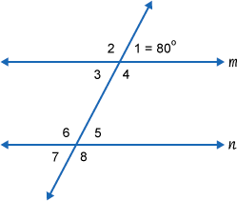

21.https://my.westcottcourses.com/images/common/angleNOarc.gif1

22.https://my.westcottcourses.com/images/common/angleNOarc.gif2

23.https://my.westcottcourses.com/images/common/angleNOarc.gif3

24.https://my.westcottcourses.com/images/common/angleNOarc.gif4

25.https://my.westcottcourses.com/images/common/angleNOarc.gif5

26.https://my.westcottcourses.com/images/common/angleNOarc.gif6

27.https://my.westcottcourses.com/images/common/angleNOarc.gif7

28.https://my.westcottcourses.com/images/common/angleNOarc.gif8

Given m || n, find x:

29.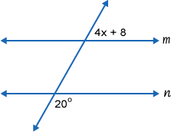

30.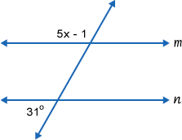

31.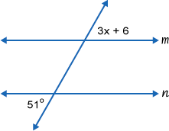

32.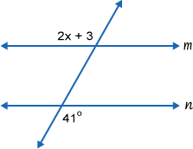

33.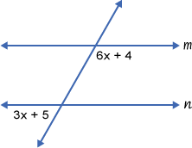

34.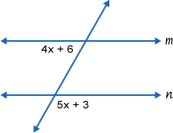

Find angles x and y:

35.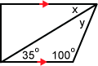

36.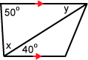

37.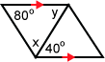

38.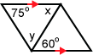

Prove the following:

39.Prove Theorem 1.6.1:  
If two parallel lines are cut by a transversal, then the alternate interior angles are congruent.

40.Prove Theorem 1.6.5:  
Two lines are perpendicular if and only if they form four right angles.

41.Prove Theorem 1.6.2:  
If two lines are cut by a transversal and one pair of alternate interior angles are congruent, then the other pair of alternate interior angles also are congruent.

42.Prove Theorem 1.6.3:  
If two lines are cut by a transversal and one pair of corresponding angles are congruent, then all pairs of corresponding angles are congruent.

43.Prove Theorem 1.6.4:  
If two lines are cut by a transversal and a pair of alternate interior angles are congruent, then the two lines are parallel.

44.Given:   https://my.westcottcourses.com/images/common/angleNOarc.gif3 https://my.westcottcourses.com/images/common/congruence.gif https://my.westcottcourses.com/images/common/angleNOarc.gif4  
    https://my.westcottcourses.com/images/common/angleNOarc.gif1 https://my.westcottcourses.com/images/common/congruence.gif https://my.westcottcourses.com/images/common/angleNOarc.gifC  
  
Prove:   DE || AC  
  
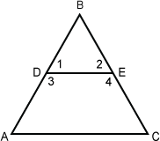

45.Given:   https://my.westcottcourses.com/images/common/angleNOarc.gifF and https://my.westcottcourses.com/images/common/angleNOarc.gif1   are complementary  
    https://my.westcottcourses.com/images/common/angleNOarc.gifE and https://my.westcottcourses.com/images/common/angleNOarc.gif2   are complementary  
  
Prove:  AF  ||  DE  
